

ASSET VERIFICATION AND RECORDING TOOL KIT


Plot 31, Bukoto Street
P.O Box 7657, Kampala, Uganda
+256 (0) 39 2000216/0772525235
email: cpa@cpa.ug

www.cpa.com

August to September 2026

VERIFICATION DETAILS

NAME OF THE REGION: | NORTHERN REGION
SUB-REGION: | LANGO SUB-REGION
Name of Local Government | OTUKE DISTRICT LOCAL GOVERNMENT
VERIFIER PARTICULARS
Full name | AGANYO MERCY
Contact/ email and Telephone | 0786551826  mercyaganyo22@gmail.com
Supervisor/ Sub team leader
Name | MR. DENIS
Contact | 0779622063
Date of submission | 29TH AUGUST 2026

HEALTH CENTRES
INFORMANT INTERVIEW/DISCUSSION GUIDE (INCHARGE OR RESPONSIBLE PERSON)

Name of Health Centre: ALANGO HEALTH CENTRE III

1a | Does the Facility have a record of all assets provided under UgIFT.  (Obtain a record and verify if it has the costs and numbers supplied | YES
1b | If Not ask how many were supplied and when.

2 | How does this facility Maintain (repair/service/replace) the assets provided under Ugift

3 | Does the facility take regular record about functionality/ or breakdown of the assets provided?

YES, The facility always conducts regular evaluation and takes records of the functionality of the equipment provided.

4 | How has the UgIFT support helped in service delivery in the area, any issues, challenges and any recommendations for better program implementation.

The UGIFTS support has improved the Health of community for example expectant mothers can now put to bed within the facility due to the equipment provided, the hospital is now well equipped.
Recommendation UGIFT should help to construct staff houses because most staff members are residing outside the facility.

PROCEED TO VERIFICATION AFTER THIS DISCUSSION

Health center checklist

NAME OF LG OTUKE DISTRICT LOCAL GOVERNMENT. NAME OF HEALTH FACILITY ALANGO HEALTH CENTRE III

Equipment/ Item | Department | Asset Number | Item  Description | Life in Months | Tag Number ( engrave no.) | Date Of Purchase | Date Placed In Service | Recoverable cost | Cost | Acc Dep Cost | Net Book Value | Ytd Deprn | Equipment status | Remarks
B.P. Machine, Digital (3) | MCH(2)  OPD(1) |  | Digital | 60 | Not engraved | 15/11/2025 | May 2026 |  |  |  |  |  | Functional | Good working condition
B.P. Machine (Aneroid wall mounted) (2) | OPD  MCH |  | Manual | 60 | Not engraved | 15/11/2025 | May 2026 |  |  |  |  |  | Functional | Good condition
Autoclave 20 Liters.,Duo Operated (1) | MCH |  | Plastic | 60 | Not engraved | 15/11/2025 | May 2026 |  |  |  |  |  | Functional | Good condition
Bowl, Kick (2) | MCH |  | Metallic | 60 | Not engraved | 15/11/2025 | May 2026 |  |  |  |  |  | Functional | Good condition
Bowl Stand (2) | MCH |  | Metallic | 60 | Not engraved | 15/11/2025 | May, 2026 |  |  |  |  |  | Functional | Good Working condition
Counting chamber Neubauer- Improved (2) | MCH |  | Plastic |  | Not engraved | 15/11/2025 | May, 2026 |  |  |  |  |  | Functional | Good Working condition
Cupboard Steel, Lockable (3) | MCH |  | Metallic | 80 | Not engraved | 15/11/2025 | May, 2026 |  |  |  |  |  | Functional | Good Working condition
Drip Stand | - |  | - | - | - | - | - | - | - | - | - | - | - | -
ESR Stand (1) | LAB |  | Glass in nature | 70 | Not engraved | 15/11/2025 | May, 2026 |  |  |  |  |  | Functional | Good working condition
Examination Couch (4) | MCH(2)  OPD (2) |  | Metallic with cushion | 120 | Not engraved | 15/11/2025 | May, 2026 |  |  |  |  |  | Functional | Good working condition
Examination light,LED (2) | MCH |  | Plastic | 60 | Not engraved | 15/11/2025 | May, 2026 |  |  |  |  |  | Functional | Good working condition
Glucometer (4) | LAB  MCH |  | Plastic | 60 | Not engraved | 15/11/2025 | May, 2026 |  |  |  |  |  | Functional | Good working condition
Haemoglobin Meter, Digital (2) | LAB  MCH |  | Plastic  Digital | 60 | Not engraved | 15/11/2025 | May, 2026 |  |  |  |  |  | Functional | Good Condition
Height Meter (2) | OPD  MCH |  | Plastic | 60 | Not engraved | 15/11/2025 | May, 2026 |  |  |  |  |  | Functional | Good working condition
Instrument Trolley (1) | MCH |  | Metallic | 60 | Not engraved | 15/11/2025 | May, 2026 |  |  |  |  |  | Functional | Good working condition
Microscope Binocular (1) | LAB |  | Metallic electrical | 70 | Not engraved | 15/11/2025 | May, 2026 |  |  |  |  |  | Functional | Good working condition
Otoscope (1) | OPD  MCH |  | Metallic | 90 | Not engraved | 15/11/2025 | May, 2026 |  |  |  |  |  | Functional | Good working condition
Patient Screen (1) | MCH |  | Metallic | 70 | Not engraved | 15/11/2025 | May, 2026 |  |  |  |  |  | Functional | Good conditionN
Patient Trolley (2) | Ward MCH |  | Metallic | 80 | Not engraved | 15/11/2025 | May, 2026 |  |  |  |  |  | Functional | Good working condition
Refrigerator, Basic (1) | MCH |  | Metallic | 90 | Not engraved | 15/11/2025 | May, 2026 |  |  |  |  |  | Functional | Good working condition
Stethoscope (12) | OPD MCH Store |  | Metallic with rubber | 60 | Not engraved | 15/11/2025 | May, 2026 |  |  |  |  |  | Functional | Good working condition and 4 are still in the store
Stop Watch (2) | MCH |  | Metallic | 60 | Not engraved | 15/11/2025 | May, 2026 |  |  |  |  |  | Functional | Good working condition
Stretcher | - | - | - | - | - | - | - | - | -- | - | - | - | - | --
Stove, Gas (1) | MCH |  | Metallic | 70 | Not engraved | 15/11/2025 | May, 2026 |  |  |  |  |  | Functional | Good condition
Weighing Scale with Height (4) Meter, Adult | OPD MCH |  | Metallic | 60 | Not engraved | 15/11/2025 | May, 2026 |  |  |  |  |  | Functional | Good working condition
Weighing Scale, Infant (4) | EPI |  | Metallic | 80 | Not engraved | 15/11/2025 | May, 2026 |  |  |  |  |  | Functional | Good condition
Weighing Scale, Toddler (2) | MCH |  | Plastic | 70 | Not engraved | 15/11/2025 | May, 2026 |  |  |  |  |  | Functional | Good condition
Wheel Chair (2) | MCH  WARD |  | Metallic with fabric | 60 | Not engraved | 15/11/2025 | May, 2026 |  |  |  |  |  | Functional | Good condition
Audio Visual Equipment - | - | - | - | - | - | -- | - | - | - | - | - | -- |  | -
Medical Waste Bin (3) | MCH |  | Plastic | 60 | Not engraved | 15/11/2025 | May, 2026 |  |  |  |  |  | Functional | Good working condition
Wall Clock (5) | LAB  OPD |  | Plastic | 60 | Not engraved | 15/11/2026 | May, 2026 |  |  |  |  |  | Functional | Good working condition
 | MCH
 | WARD
Diagnostic Equipment Set for MCH (3) | MCH |  | Metallic | 60 | Not engraved | 15/11/2025 | May, 2026 |  |  |  |  |  | Functional | Good working condition
Diagnostic Equipment Set for OPD (2) | OPD |  | Metallic | 60 | Not engraved | 15/11/2025 | May, 2026 |  |  |  |  |  | Functional | Good condition
Glassware Set, Laboratory, Basic (2) | LAB |  | Glass in nature | 60 | Not engraved | 15/11/2025 | May, 2026 |  |  |  |  |  | Functional | Good condition but they are the outdated type
Hollow Ware Set, Treatment | - | - | - | - | - | - | -- | - | - | - | - | - | - | -
Instrument Set, Dressing (2) | WARD |  | Metallic | 60 | Not engraved | 15/11/2025 | May, 2026 |  |  |  |  |  | Functional | Good condition
Instrument Set, Basic ENT | - | - | - | - | - | - | - | - | - | - | - | - | - | -
Instrument Set, Suture | - | - | - | - | - | - | - | - | - | - | - | - | - | -
Pulse Oximeter, Hand held (2) | OPD  WARD |  | Plastic | 60 | Not engraved | 15/11/2025 | May, 2026 |  |  |  |  |  | Functional | Good condition
Bed, Adult Patient with Mattress (20) | Ward MCH |  | Metallic and mattress | 120 | Not engraved | 15/11/2026 | May, 2026 |  |  |  |  |  | Functional | Good working
Bed, Pediatric Patient, With Mattress(4) | PAED |  | Metallic | 90 | Not engraved | 15/11/2025 | May, 2026 |  |  |  |  |  | Functional | Good working Condition
Bedside Locker | - | - | - | - | - | - | - | - | - | - | - | - | - | -
Cupboard, Instrument | - | - | - | - | - | -- | - | - | - | - | -- | - | - | -
Delivery Bed, Hydraulic Manual | - | - | - | - | - | - | - | - | - | - | - | - | - | -
Oxygen Therapy Apparatus, Mininum 45L cylinder | - | - | - | - | - | - | - | - | - | - | - | - | - | -
Resuscitator Manual, Infant, with all Mask sizes (3) | MCH |  | Plastic | 70 | Not engraved | 15/11/2025 | May, 2026 |  |  |  |  |  | Functional | Good condition
Resuscitator Manual, Adult, with all mask sizes (45) | WARD MCH |  | Plastic | 80 | Not engraved | 15/11/2025 | May, 2026 |  |  |  |  |  | Functional | Good condition
Suction Apparatus, (Electric) (2) | MCH |  | Electric | 70 | Not engraved | 15/11/2025 | May, 2026 |  |  |  |  |  | Functional | Good condition
Nebulizer, Ultrasonic (2) | WARD MCH |  | Electrical | 90 | Not engraved | 15/11/2025 | May, 2026 |  |  |  |  |  | Functional | Good condition
Oxygen Concentrator, Duo Flow (4) | WARD |  |  | 120 | Not engraved | 15/11/2025 | May, 2026 |  |  |  |  |  | Functional | Good working condition
Bench (4) | MCH WARD |  | Wooden with metallic stand | 70 | Not engraved | 15/11/2025 | May, 2026 |  |  |  |  |  | Functional | Good working condition
Disinfection Buckets (9) | MCH |  | Plastic | 60 | Not engraved | 15/11/2025 | May, 2026 |  |  |  |  |  | Functional | Good condition
Baby Cot (2) | MCH |  | Plastic | 70 | Not engraved | 15/11/2025 | May, 2026 |  |  |  |  |  | Functional | Good condition
Diagnostic Equipment Set for Ward (3) | IPD  PN |  | Metallic | 90 | Not engraved | 15/11/2025 | May, 2026 |  |  |  |  |  | Functional | Good working condition
Hollow Ware Set, Ward (1) | Inpatient Ward |  | Metallic | 60 | Not engraved | 15/11/2025 | May, 2026 |  |  |  |  |  | Functional | Good condition
Instrument Set, Delivery (5) | MCH |  | Metallic | 60 | Not engraved | 15/11/2026 | May, 2026 |  |  |  |  |  | Functional | Good condition
Instrument Set, Stitch Removing | - | - | - | - | - | - | - | -- | - | - | - | -- | - | -
MVA Kit (6) | MCH |  | Plastic | 60 | Not engraved | 15/11/2025 | May, 2026 |  |  |  |  |  | Functional | Good working condition
Stool, Laboratory (1) | LAB |  | Metallic with cushion | 60 | Not engraved | 15/11/2025 | May, 2026 |  |  |  |  |  | Functional | Good working
Penguin Sucker (6) | MCH STORE |  | Plastic | 70 | Not engraved | 15/11/2025 | May, 2026 |  |  |  |  |  | Functional | Good condition but 2 are still in store
Fetoscope, Dopplar (02) | MCH |  | Plastic | 60 | Not engraved | 15/11/2025 | May, 2026 |  |  |  |  |  | Functional | Good condition
Bubble CPAP (2) | MCH |  | Plastic | 90 | Not engraved | 15/11/2025 | May, 2026 |  |  |  |  |  | Functional | Good condition
Centrifuge (Electric) (1) | LAB |  | Electrical | 90 | Not engraved | 15/11/2025 | May, 2026 |  |  |  |  |  | Functional | Good condition
Kangaroo Mother Care Chair (1) | MCH |  | Metallic with cushion | 80 | Not engraved | 15/11/2025 | May, 2026 |  |  |  |  |  | Functional | Good condition
Radiant Infant Warmer (1) | MCH |  | Electrical | 120 | Not engraved | 15/11/2025 | May, 2026 |  |  |  |  |  | Functional | Good condition
Haemoglobin Meter, Sahli (2) | LAB MCH |  | Manual | 60 | Not engraved | 15/11/2025 | May, 2026 |  |  |  |  |  | Functional | Good condition
Delivery Bed (3) | MCH |  | Metallic with mattress | 120 | Not engraved | 15/11/2025 | May, 2026 |  |  |  |  |  | Functional | Good working condition
Examination light | - | - | - | - | - | - | - | - | - | - | - | - | - | -
Instrument set, ENT Basic for HCIII | - | - | - | - | - | - | - | - | - | - | - | - | - | -
Bag Valve mask (Ambu Bag), Neonatal | - | - | - | - | - | - | - | - | - | - | - | - | - | -
Incubator | - | - | - | - | - | - | - | - | - | - | - | - | - | -
Office Chair (7) | OPD MCH LAB |  | Metallic with leather | 90 | Not engraved | 15/11/2025 | May, 2026 |  |  |  |  |  | Functional | Good working condition
Desk (6) | OPD MCH LAB |  | Wooden | 90 | Not engraved | 15/11/2025 | May, 2026 |  |  |  |  |  | Functional | Good working condition
Filing Cabinet (2) | IPI MCH |  | Metallic | 120 | Not engraved | 15/11/2025 | May, 2026 |  |  |  |  |  | Functional | Good working condition
Non Residential Buildings (01) | Health |  | Concrete building | 200 | Not engraved | 15/11/2025 | May 2025 |  |  |  |  |  | Functional | Good condition
Residential Buildings (02) | MCH |  | Concrete block building | 600 | Not engraved | 15/11/2025 | May 2026 |  |  |  |  |  | Functional | Good condition

SCHOOL VERIFICATION CHECKLIST

SCHOOL INTERVIEW/DISCUSSION GUIDE

Name of school: OGOR SEED SECONDARY SCHOOL

1a | Does the Facility have a record of all assets provided under UgIFT.  (Obtain a record and verify if it has the costs and numbers supplied | YES
1b | If Not ask how many were supplied and when.

2 | How does this facility Maintain (repair/service/replace) the assets provided under Ugift

OGOR SEED SECONDARY SCHOOL uses USE and PTA contribution to repair and maintain the assets provided in a good condition.

3 | Does the facility take regular record about functionality/ or breakdown of the assets provided?  Nonfunctional/ working, and reasons for non-functionality.

Yes, Ogor Seed Secondary School always does regular checkups of the assests provided to ensure that they are functioning well.

4 | How has the UgIFT support helped in service delivery in the area, any issues, challenges and any recommendations for better program implementation.

The assets have improved the education of the community for example the computers provided has digital learning.
Recommendation; UGIFT should construct more classrooms in the school to accommodate the increasing numbers of learners.

PROCEED TO VERIFICATION AFTER THIS DISCUSSION

SCHOOL FURNITURE
(School Desks, Office chairs, Laboratory stools, Book shelves)

Name of LG OTUKE DISTRICT LOCAL GOVERNMENT Name of SCHOOL OGOR SEED SECONDARY SCHOOL
Equipment/ Item | Department | Asset Number | Item  Description | Life in Months | Tag Number ( engrave no.) | Date Of Pur | Date Placed In Service | Recoverable cost | Cost | Acc Dep Cost | Net Book Value | Ytd Deprn | Equipment status | Remarks
School Desk 120 |  |  | Wooden | 80 |  | Jan, 2022 | Feb, 2022 |  |  |  |  |  | Functional | The desks are in a good working condition except that 10 desks are broken
Office Chairs (20) |  |  | Metallic with cushion |  |  | Jan, 2022 | Feb, 2022 |  |  |  |  |  | Functional | They are all in good working condition
Laboratory stools (192) |  |  | Wooden and metallic in nature | 80 |  | Jan, 2022 | Feb, 2022 |  |  |  |  |  | Functional | 189 stools are in a good working condition 3 stools are broken
Bookshelves |  |  | Wooden | 80 |  | Jan, 2022 | Feb, 2022 |  |  |  |  |  | Functional | They are all in a good working condition

ICT ITEMS TO VERIFY
(Desktop Computer, Server Processor, Network Switch 24 Port, Multipurpose Printer, UPS, Projector, Air Conditioners, Server, CCTV Camera)

Name of LG OTUKE DISTRICT LOCAL GOVERNMENT Name of SCHOOL OGOR SEED SECONDARY SCHOOL

Equipment/ Item | Department | Asset Number | Item  Description | Life in Months | Tag Number ( engrave no.) | Date Of Pur | Date Placed In Service | Recoverable cost | Cost | Acc Dep Cost | Net Book Value | Ytd Deprn | Equipment status | Remarks
Desktop Computer (48) | Education |  | Digital | 60 |  | Jan, 2022 | Feb, 2022 |  |  |  |  |  | Functional | Good working condition
S
Server Processor (01) | Education |  | Digital | 70 |  | Jan, 2022 | Feb, 2022 |  |  |  |  |  | Functional | Good working  condition
Network switch port | - | - | - | - | - | - | - | - | - | - | - | - | - | -
-
Multipurpose printer | Education |  | Digital | 70 |  | Jan, 2022 | Feb, 2022 |  |  |  |  |  | Functional | Good working  condition
UPS | - | - | - | - | - | - | - | - | - | - | - | - | - | -
Projector | Education |  | Digital | 70 |  | Jan, 2022 | Feb, 2022 |  |  |  |  |  | Functional | Good working  condition
Air conditioner (01) | Education |  | Digital | 75 |  | Jan, 2022 | Feb, 2022 |  |  |  |  |  | Functional | Good working  condition
CCTV Camera | Education |  | Digital | 80 |  | Jan, 2022 | Feb, 2022 |  |  |  |  |  | Functional | Good working  condition

BUILDINGS TO VERIFY
(Non- Residential and Residential, Kitchen, Toilets/Pit latrine Water tanks, Fences etc.)

Name of LG OTUKE DISTRICT LOCAL GOVERNMENT Name of SCHOOL OGOR SEED SECONDARY SCHOOL

Equipment/ Item | Department | Asset Number | Item  Description | Life in Months | Tag Number ( engrave no.) | Date Of Pur | Date Placed In Service | Recoverable cost | Cost | Acc Dep Cost | Net Book Value | Ytd Deprn | Equipment status | Remarks
Classroom buildings (6) | Education |  | Block buildings | 600 |  | Jan, 2022 | Feb, 2022 |  |  |  |  |  | Functional | The buildings are in a good State
Admin block | Education |  | Block building | 600 |  | Jan, 2022 | Feb, 2022 |  |  |  |  |  | Functional | The buildings are in a good State
twin staff houses (03) | Education |  | Twin building | 600 |  | Jan, 2022 | Feb, 2022 |  |  |  |  |  | Functional | Good state
Multipurpose hall | Education |  | Block building | 600 |  | Jan, 2022 | Feb, 2022 |  |  |  |  |  | Functional | Good state
ICT and Library Block | Education |  | Block Building | 600 |  | Jan, 2022 | Feb, 2022 |  |  |  |  |  | Functional | Good state
Science Lab. | Education |  | Block building | 600 |  | Jan, 2022 | Feb, 2022 |  |  |  |  |  | Functional | Good state
Kitchen (03) | Education |  | Twin block building | 600 |  | Jan, 2022 | Feb, 2022 |  |  |  |  |  | Functional | Good state
Pit Latrine (03) | Education |  | Twin building | 400 |  | Jan, 2022 | Feb, 2022 |  |  |  |  |  | Functional | Good state
Water Tank | Education |  | Plastic with concrete building | 90 |  | Jan, 2022 | Feb, 2022 |  |  |  |  |  | Functional | Good working  condition
Fence | - | - | - | - | - | - | - | - | - | - | - | - | - | -

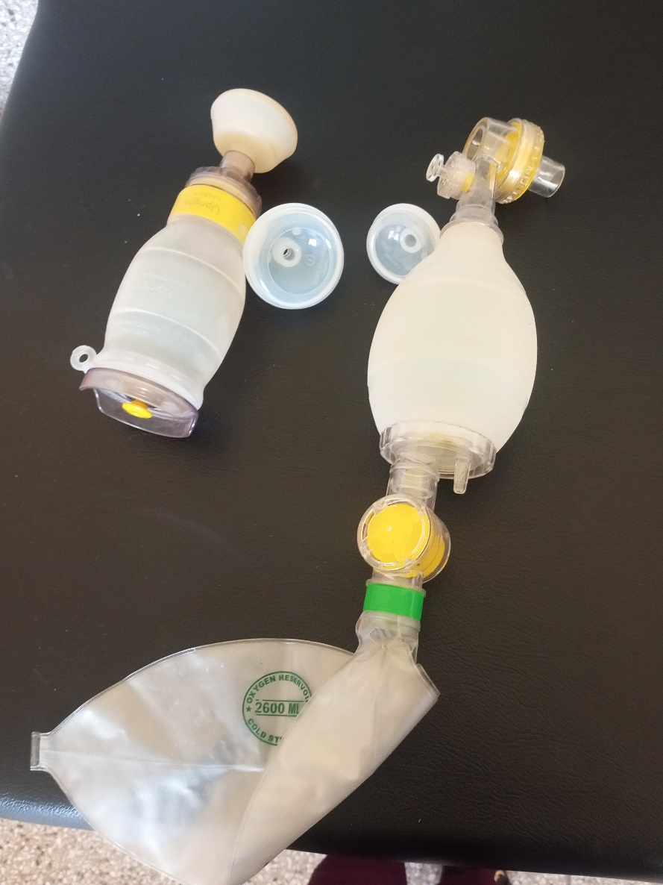
SAMPLE PICTURES OF ALANGO H/C III

Penguin Sucker

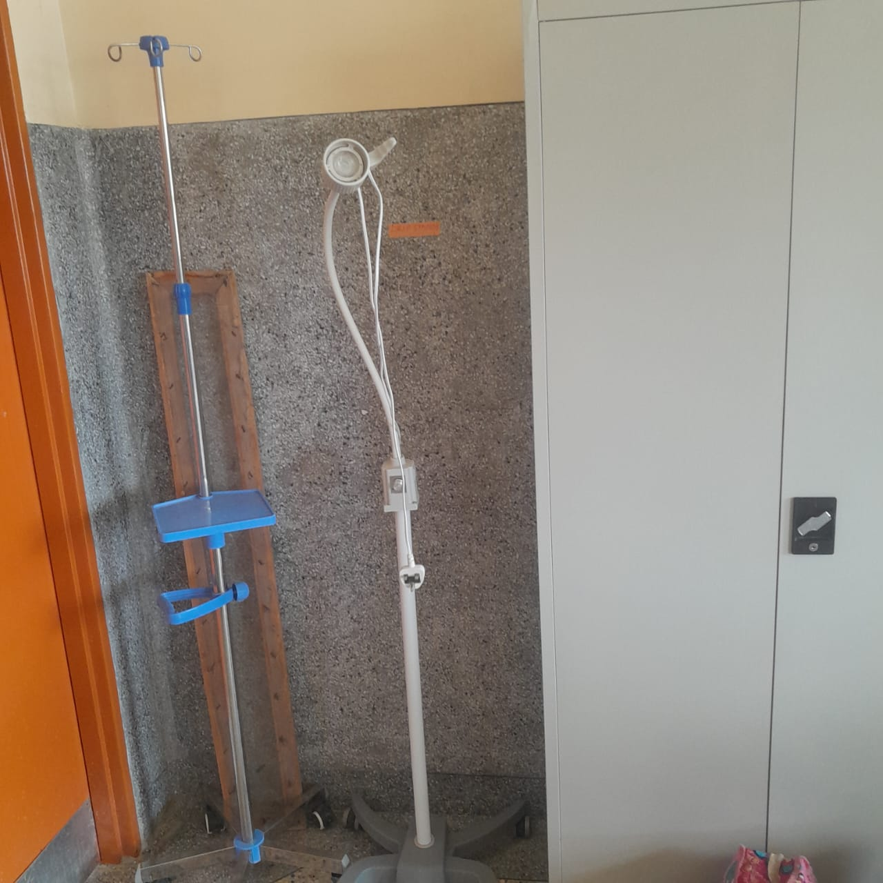

Drip Stand and Examination Light LED

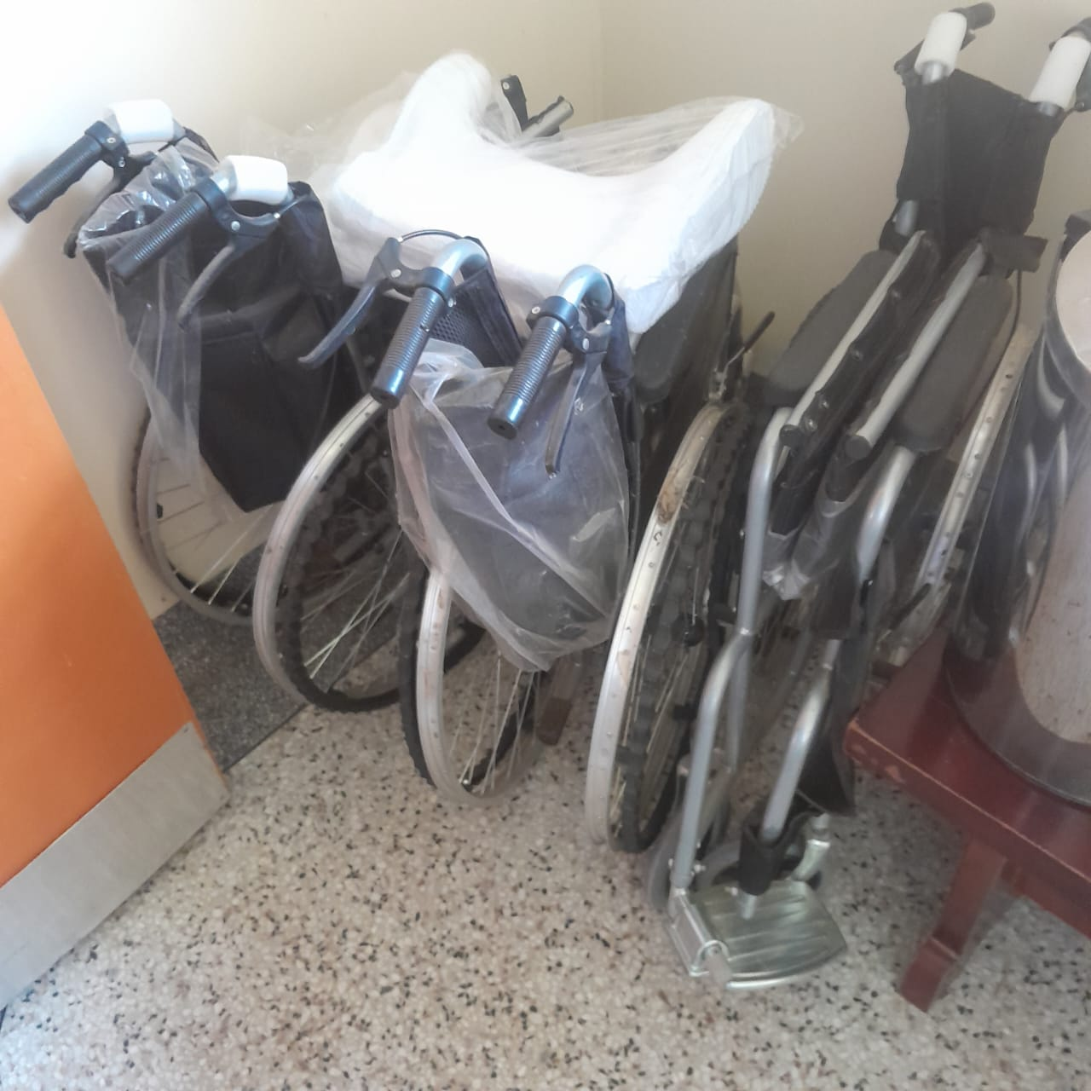

Wheel Chairs

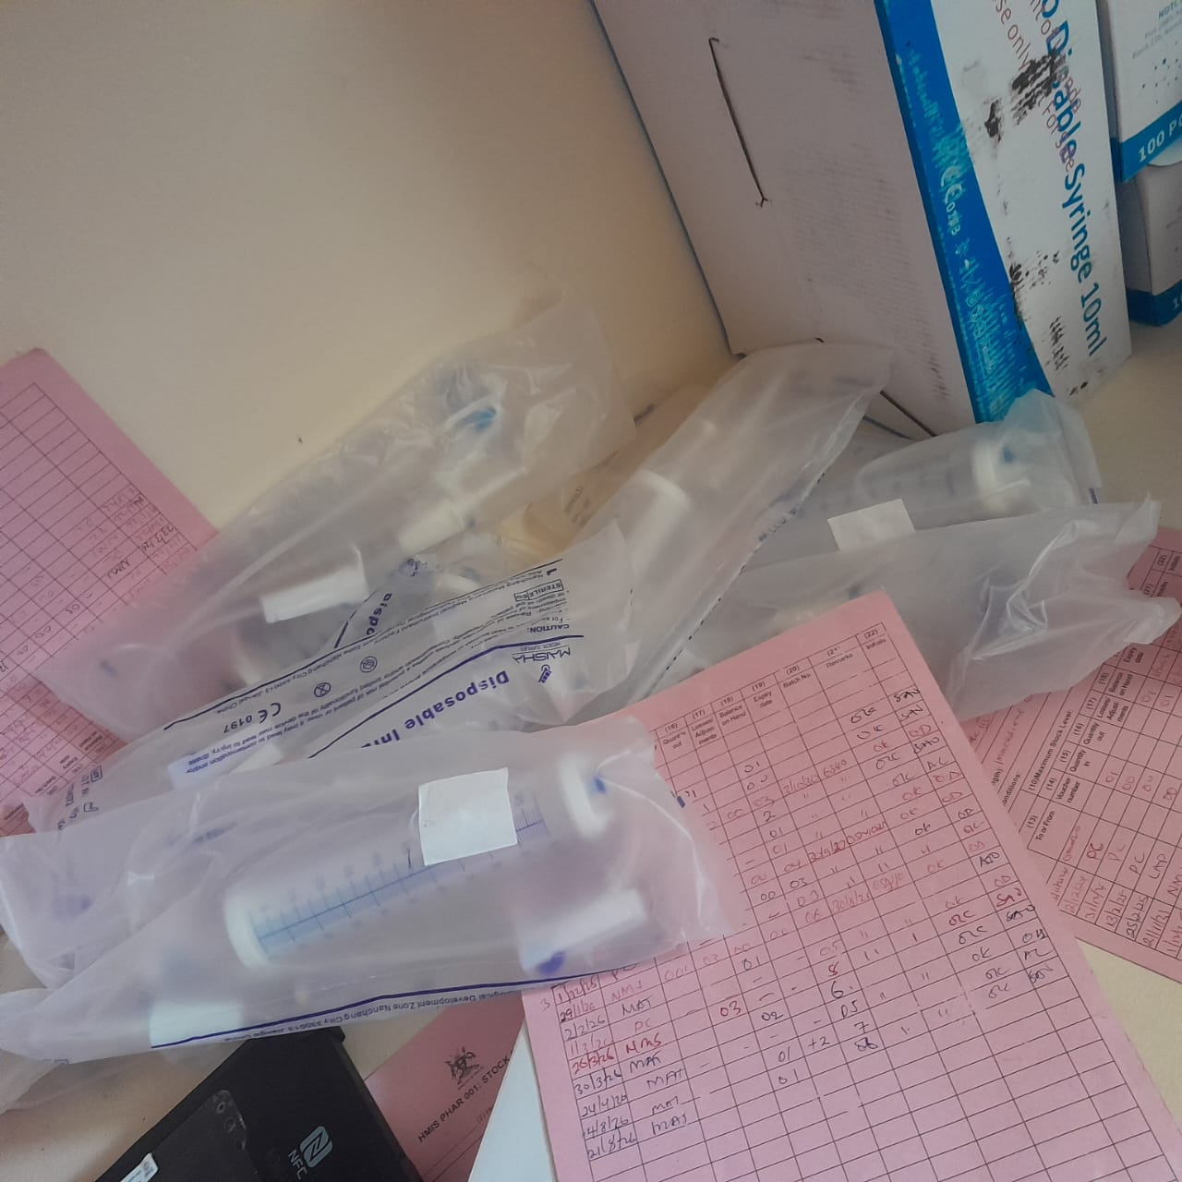

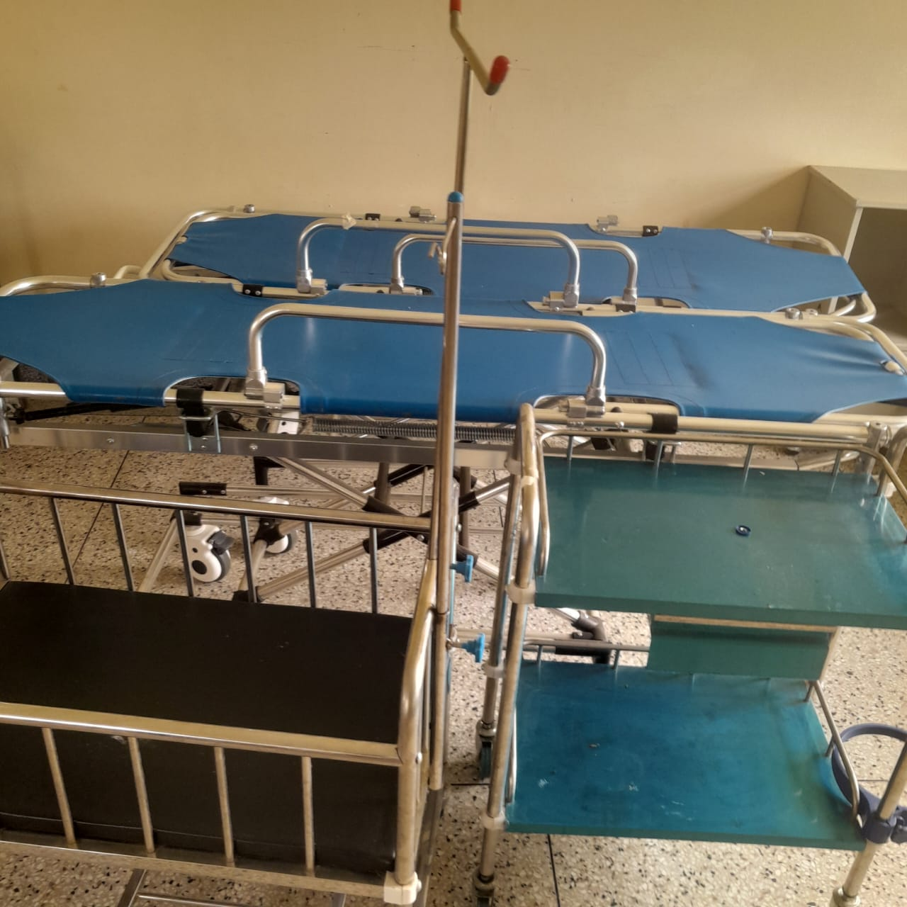

Stretcher

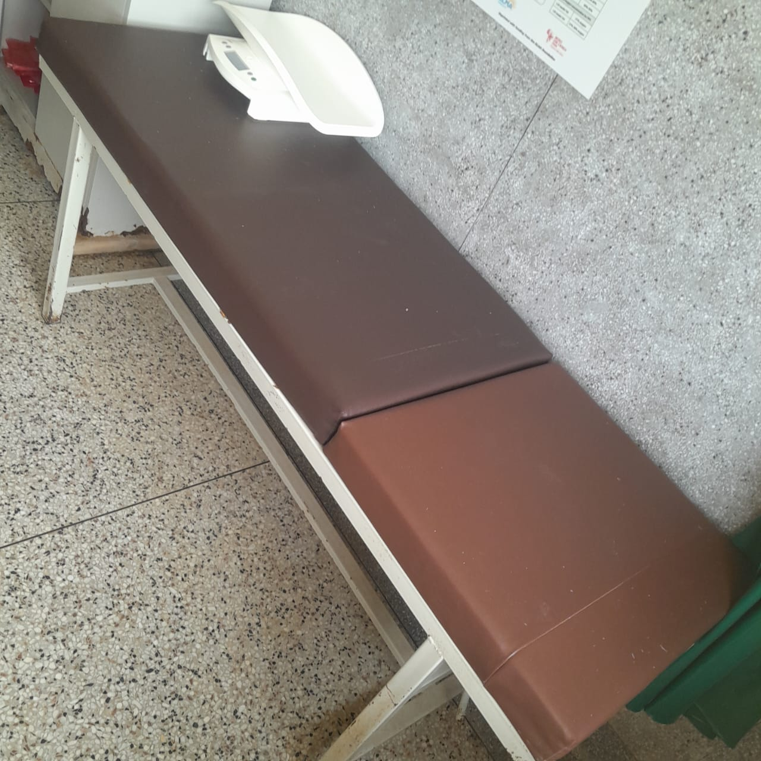

Examination Couch
and Weighing Scale
Infant

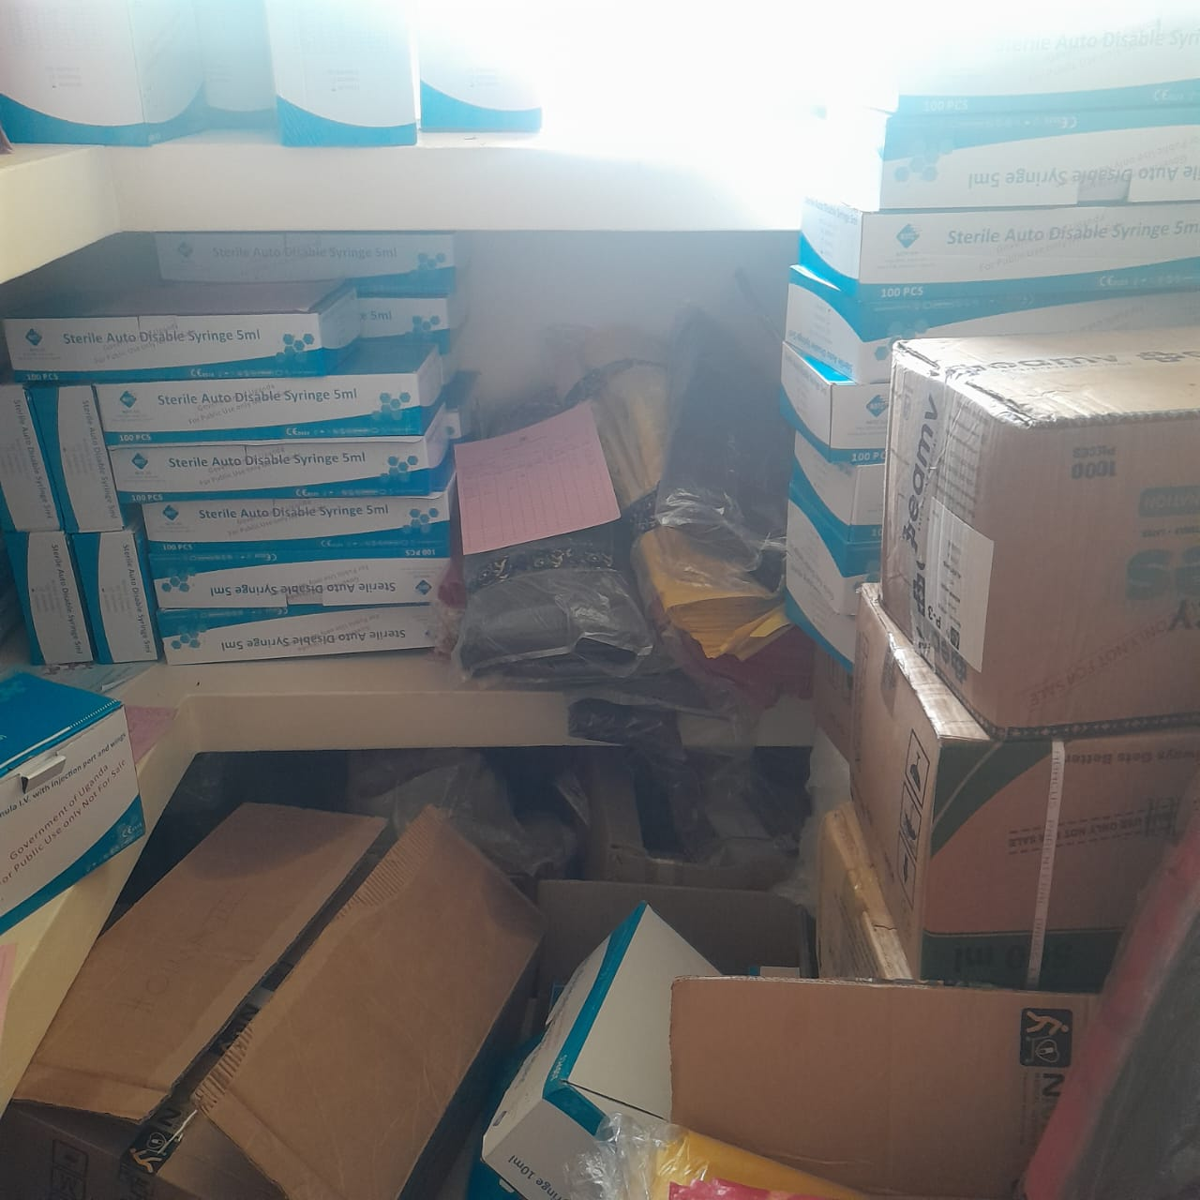

Assets in the Store

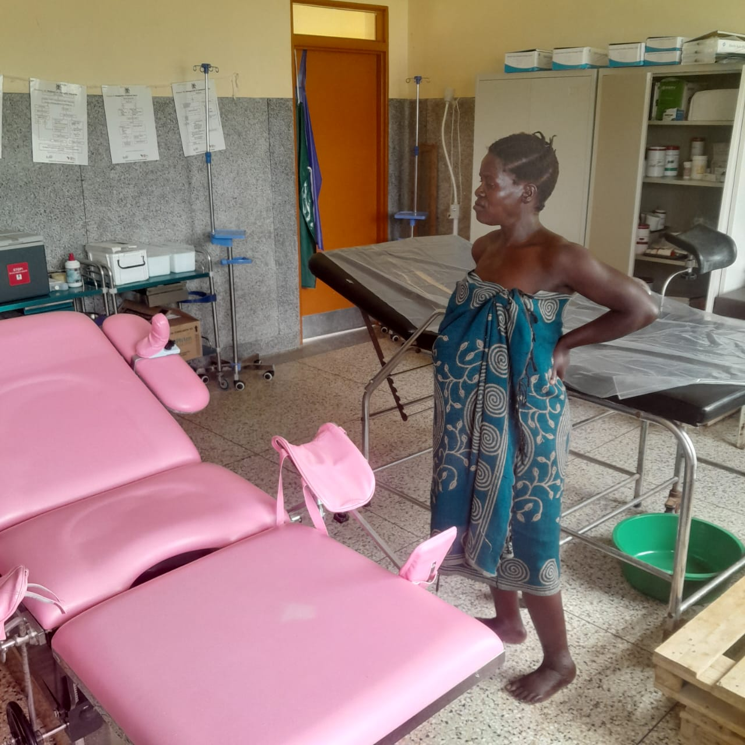

Delivery Bed Hydraulic
Manual

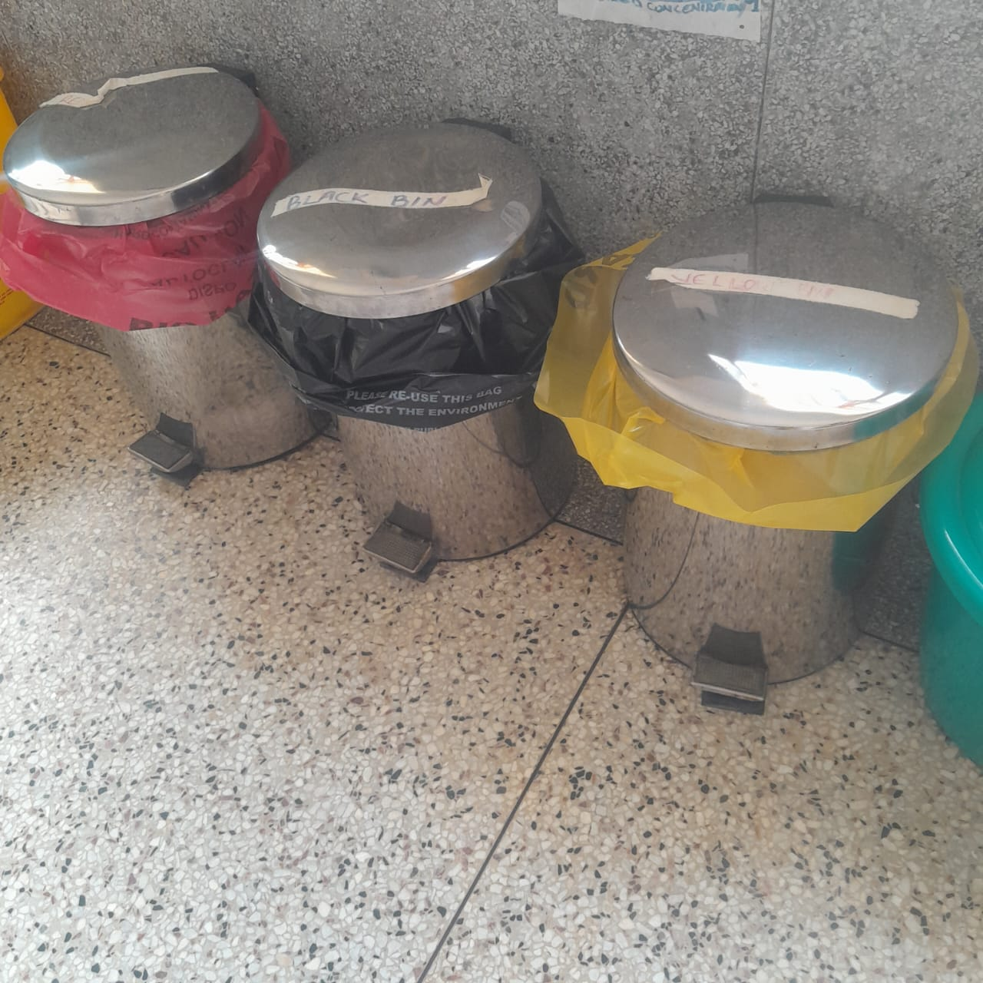

Disinfection Buckets

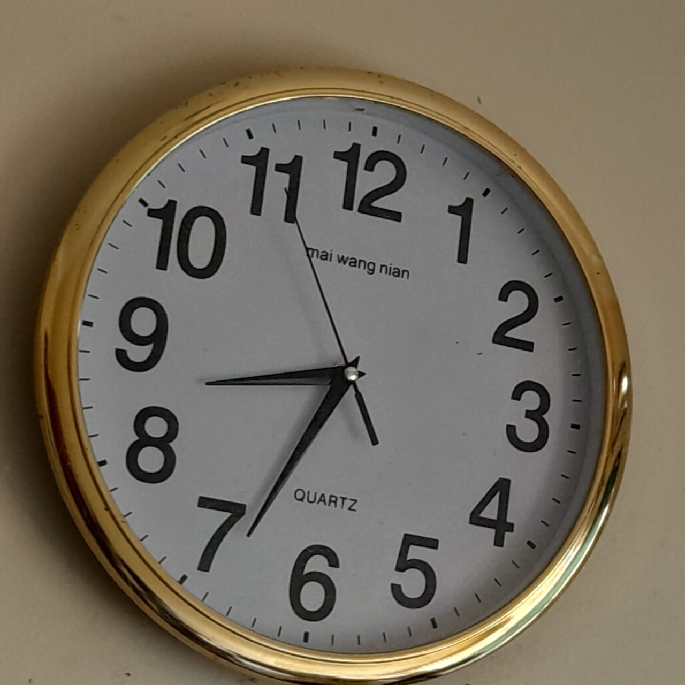

Wall Clock

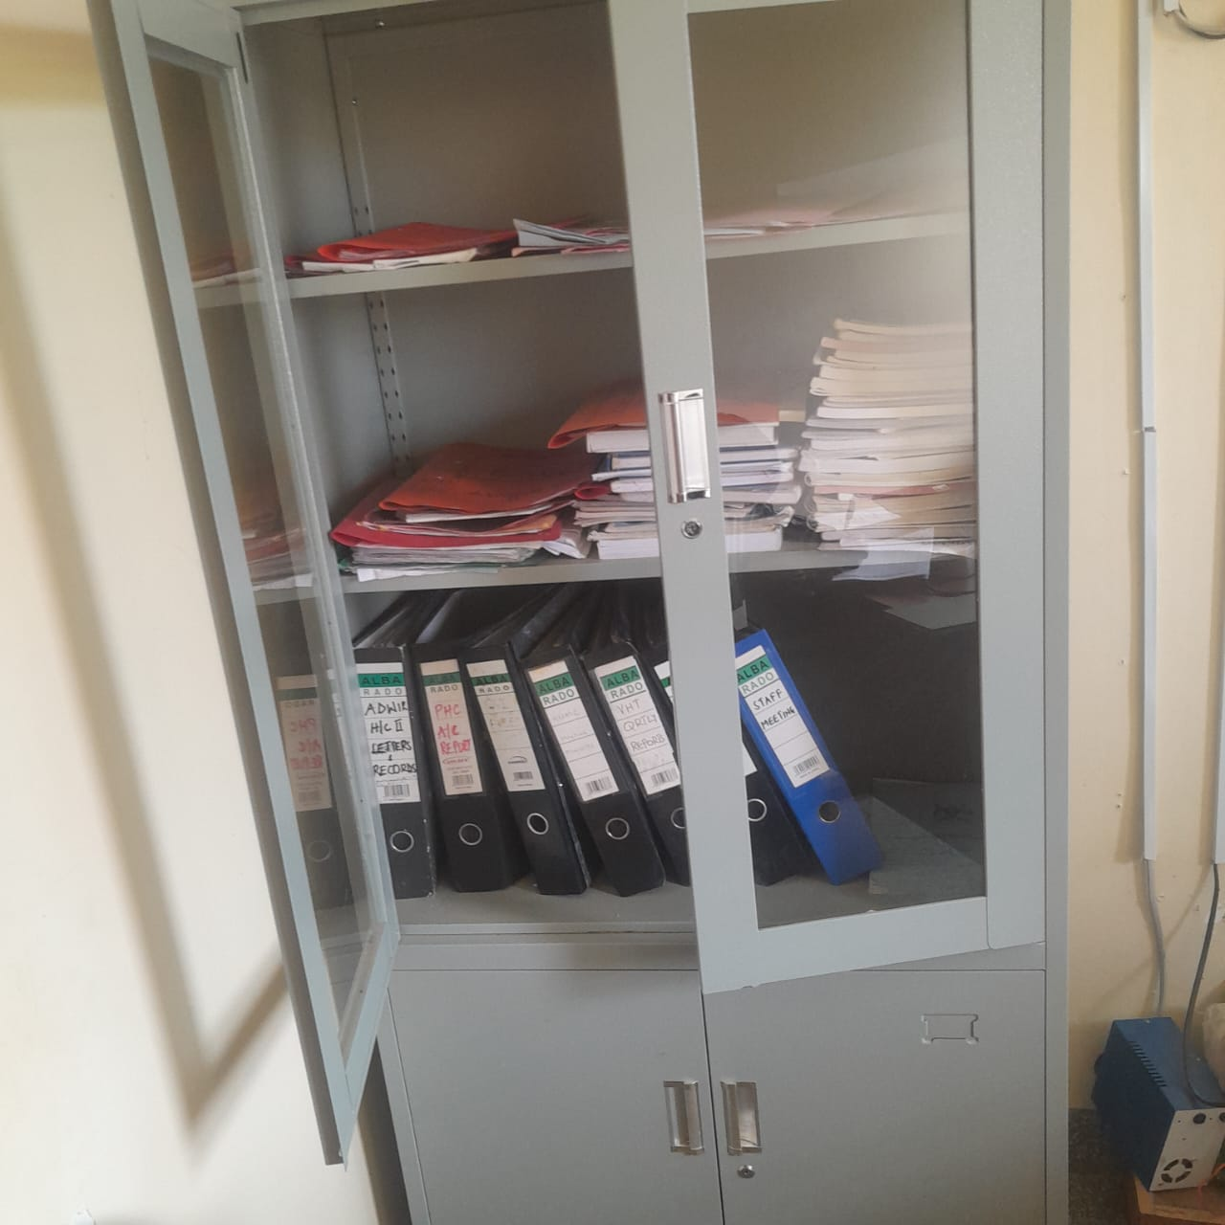

Cupboard Steel Lockable

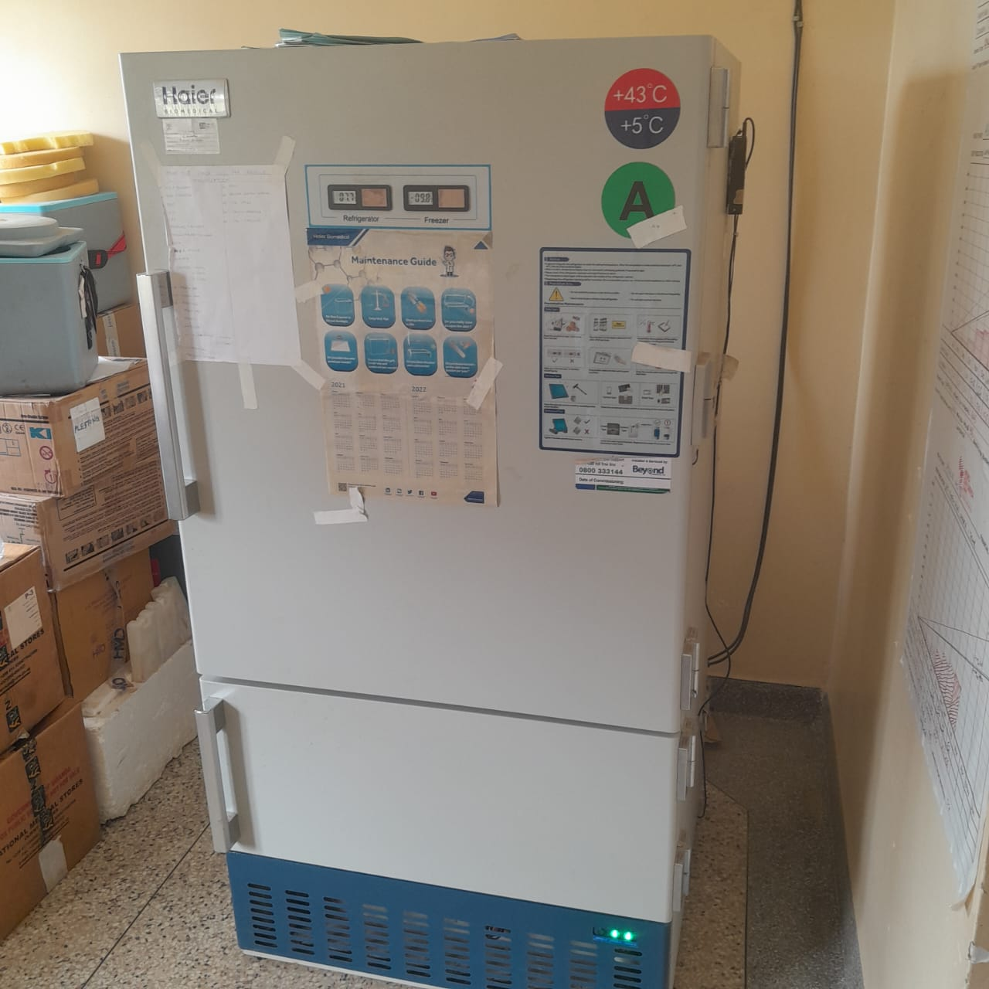

Refrigerator

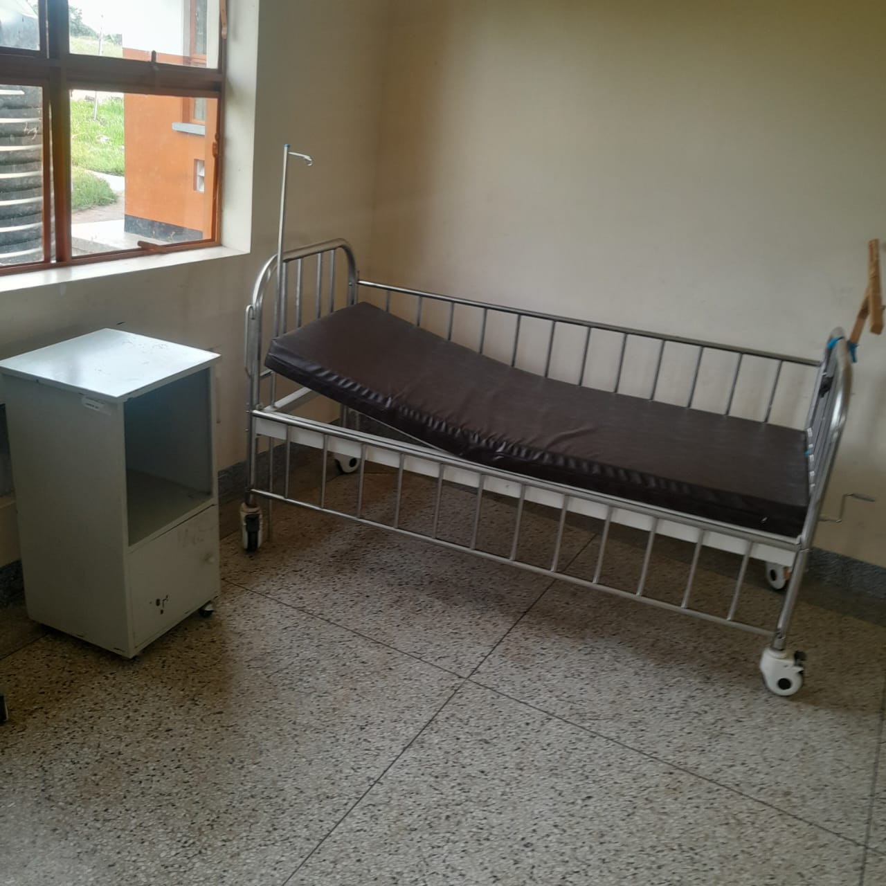

Patient Bed and Bedside Locker

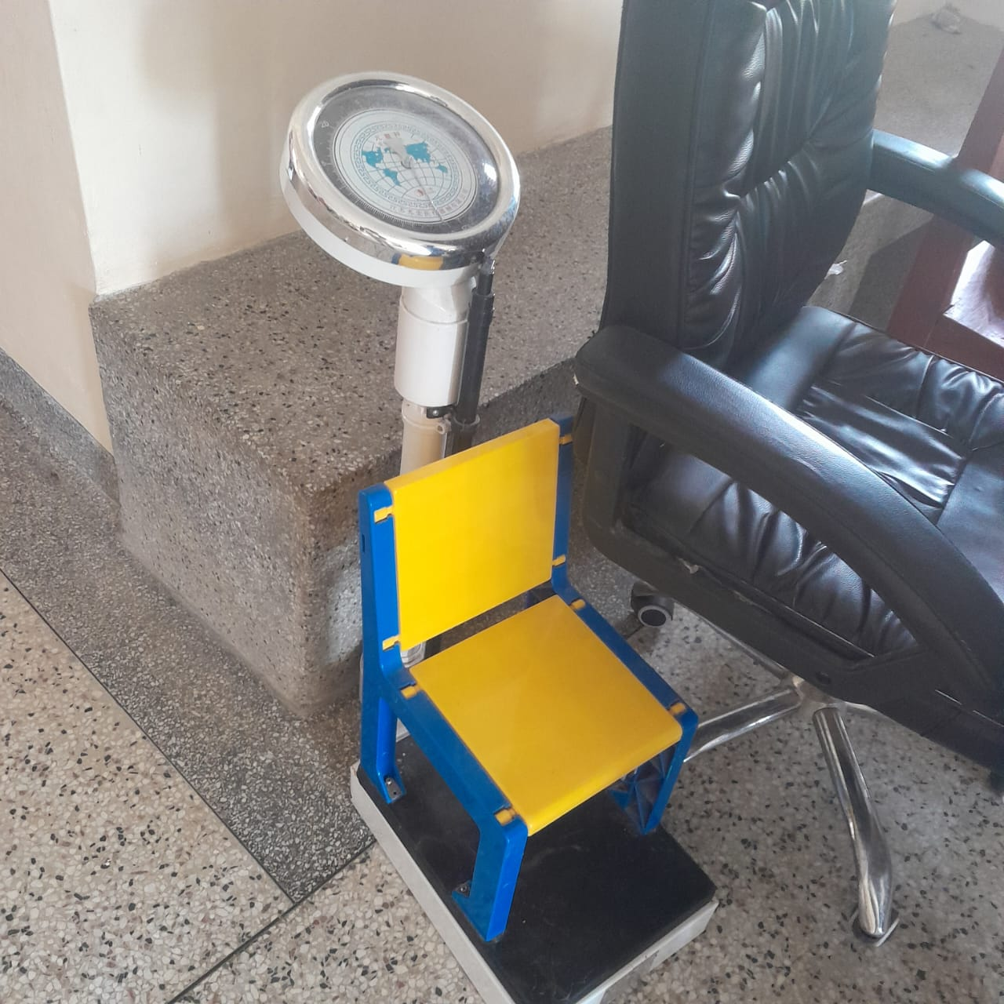

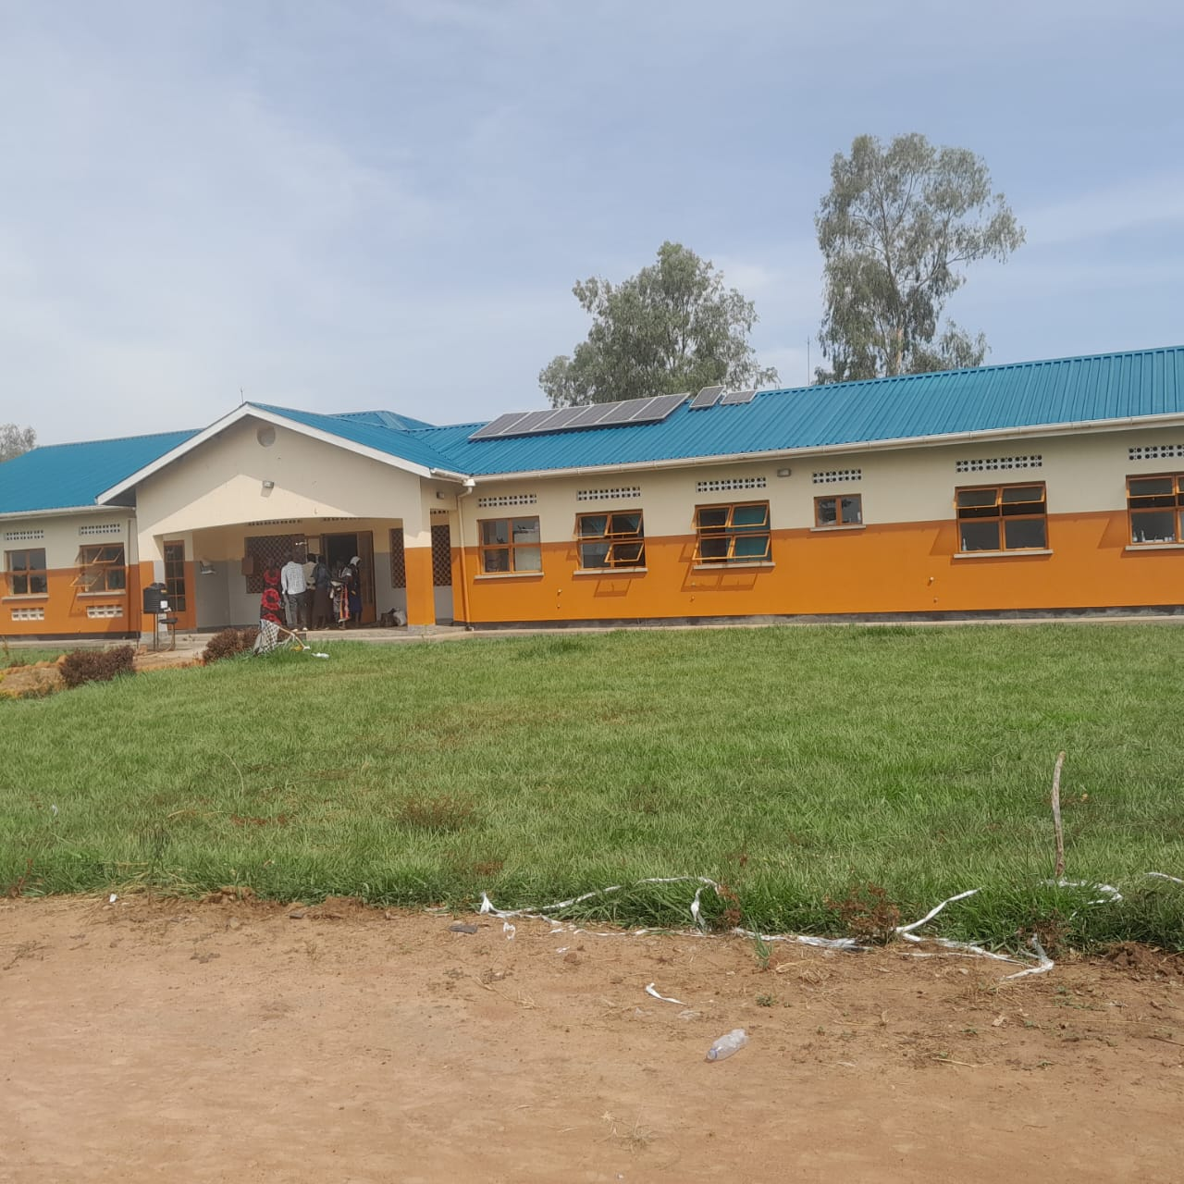

MCH Ward

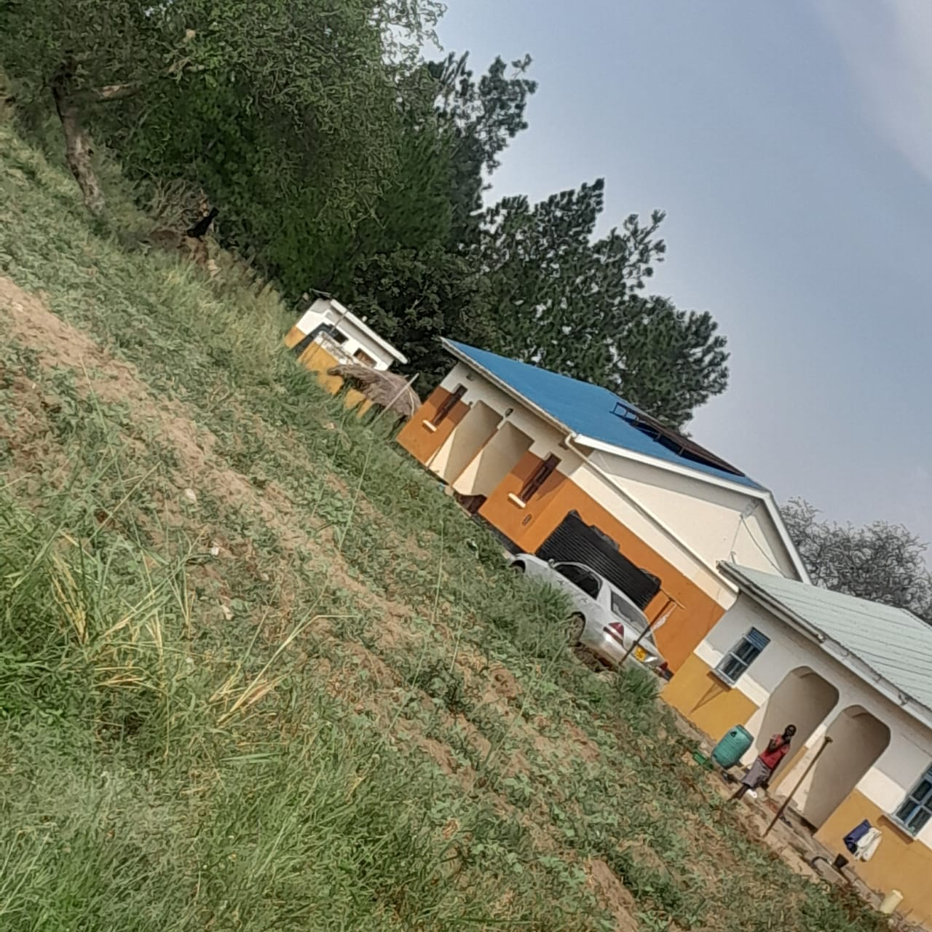

Staff Houses

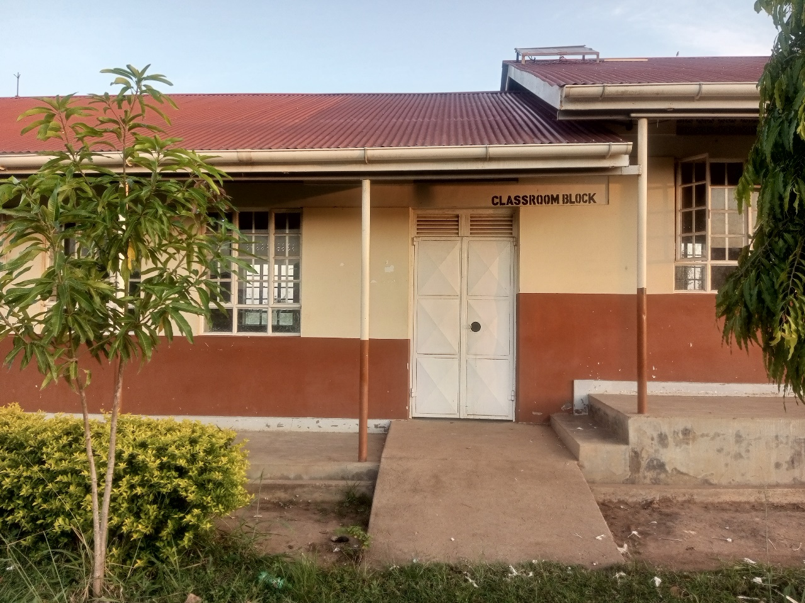
SAMPLE PICTURES OF OGOR SEED SECONDARY SCHOOL

Ogor S.S.
Classroom
Block

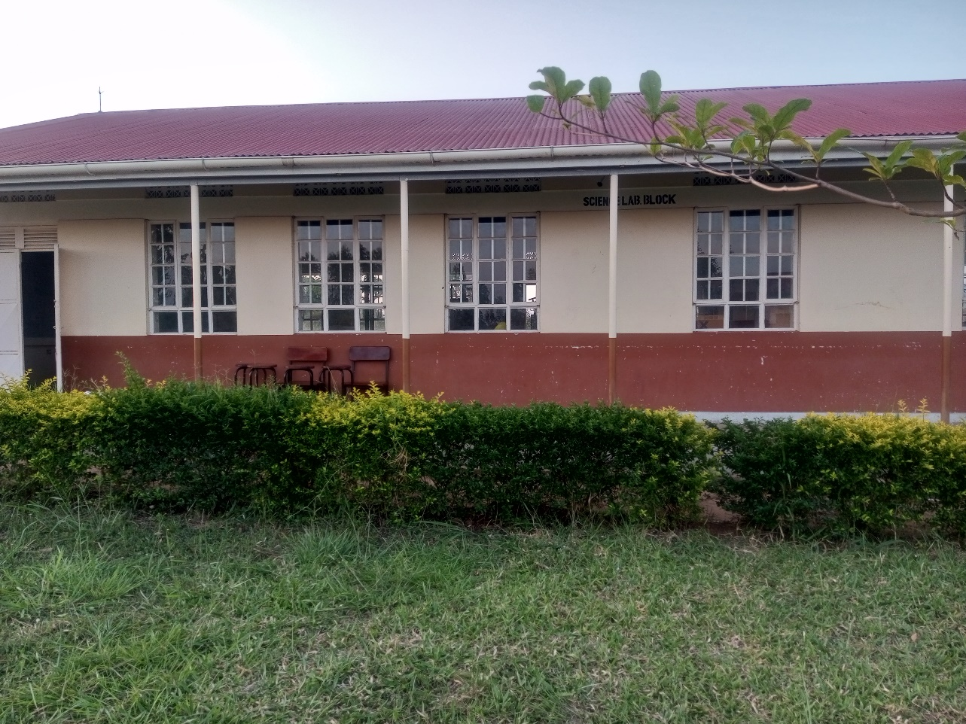

Ogor Seed
S.S Science
Laboratory

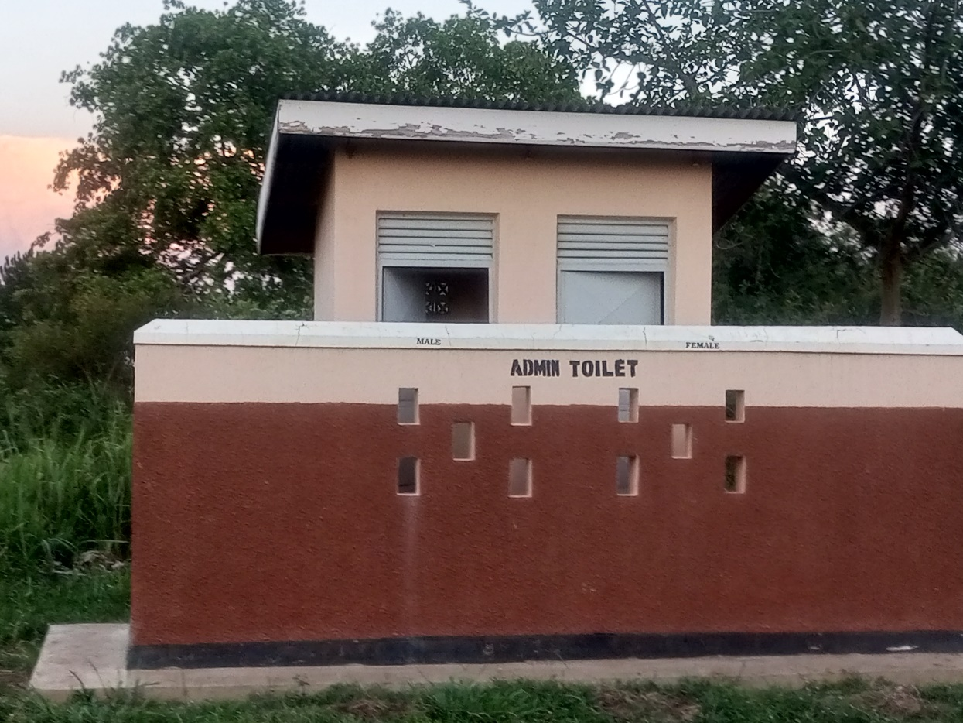

Ogor Seed
S.S
Pit Latrine

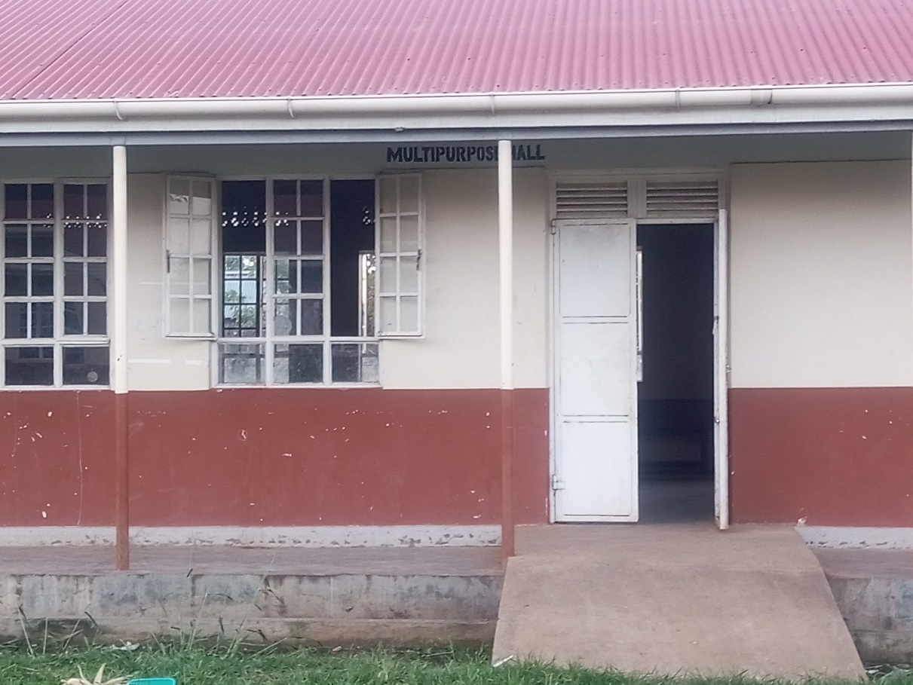

Ogor Seed S.S
Multipurpose Hall
And Library
Block

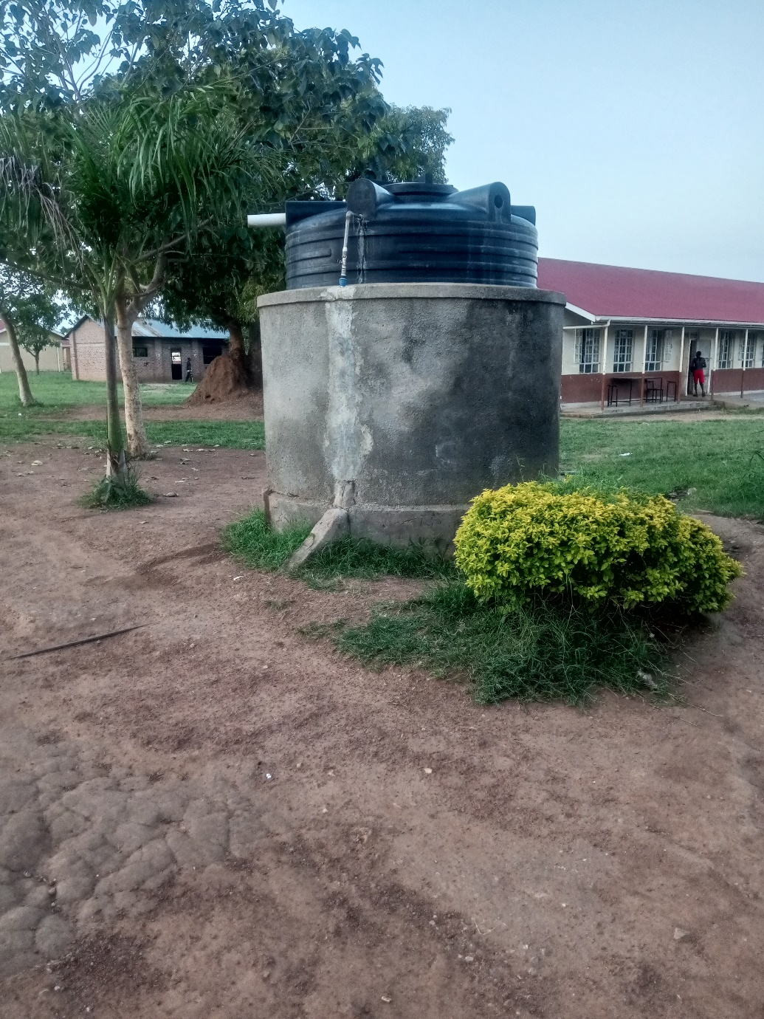

Ogor Seed S.S.
Water Tank

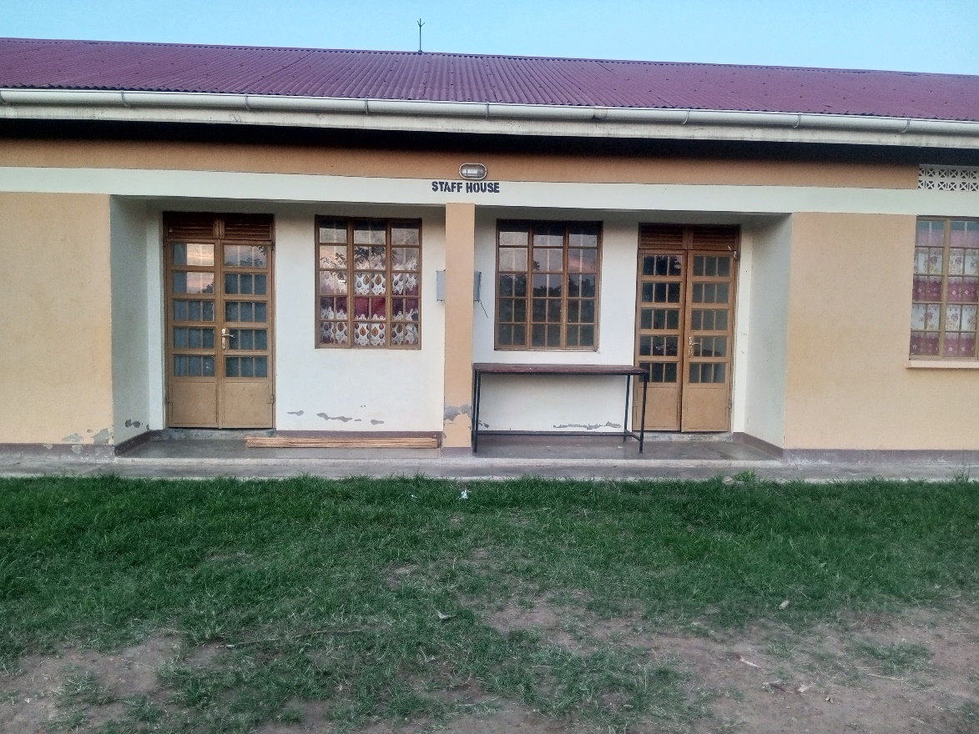

Ogor Seed S.S.
Twin Staff House

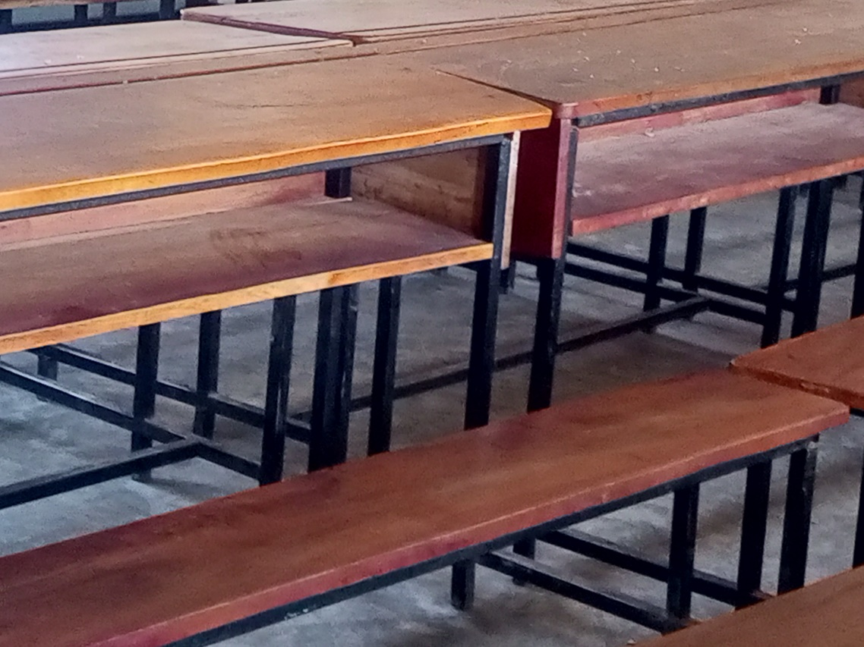

Sample of Desks

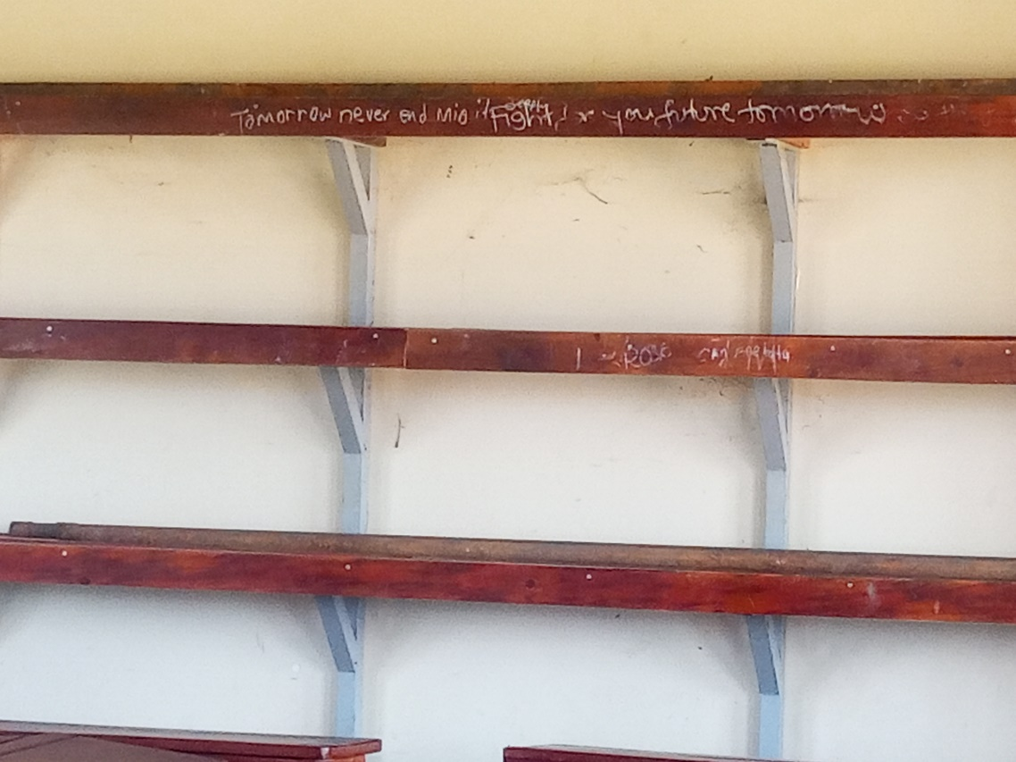

Sample of Bookshelves

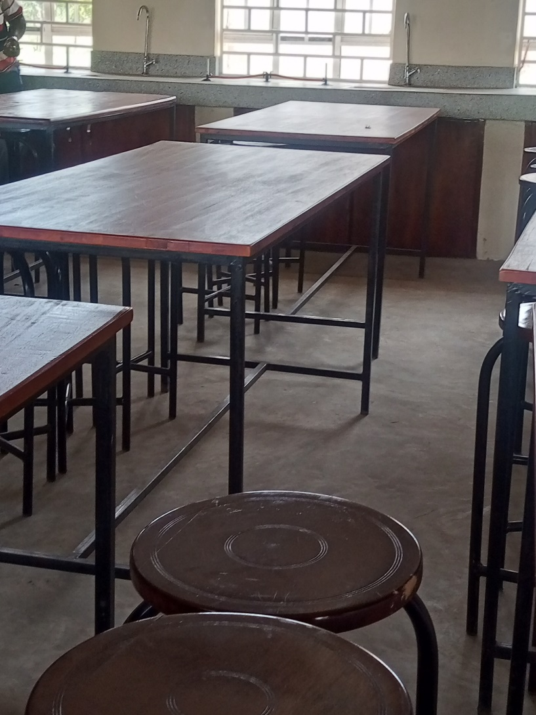

Sample of Ogor Seed S.S
Laboratory Tables

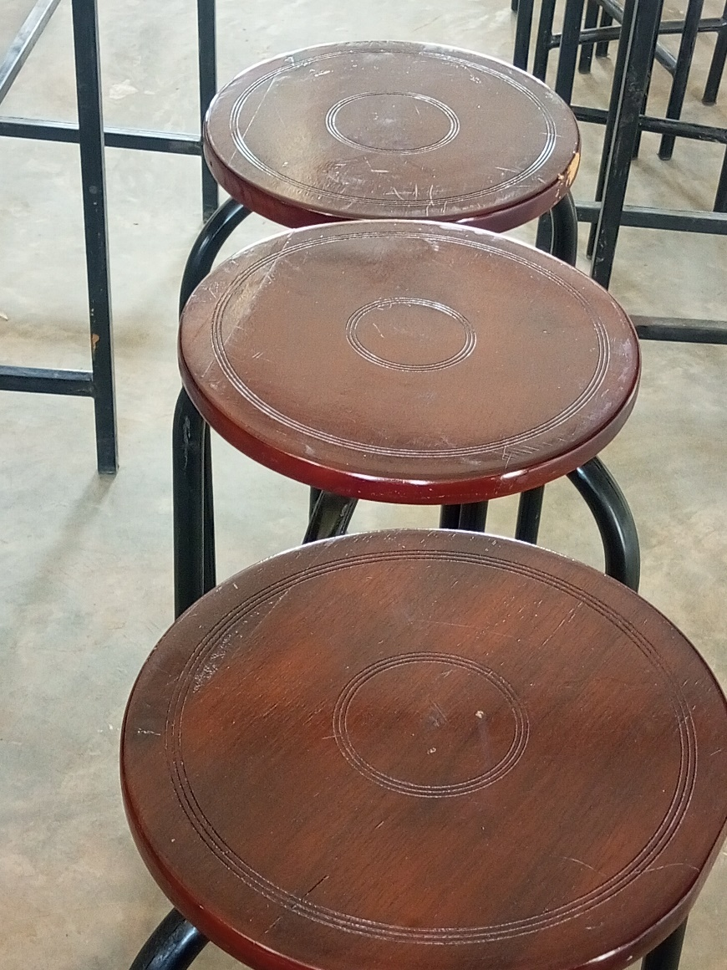

Ogor Seed S.S
Laboratory Stools Sample

